Disposition by Summary Report (350)

The disposition by summary report consists of the following tables and detailed reports which are covered later in this document:
- Direct Appeals by Disposition Method
- Applications Disposed
- Disposition of Direct Appeals

The report will prompt for a Begin and End date and then query the database to generate the tables and detailed reports shown below.

Direct Appeals by Disposition Method Table
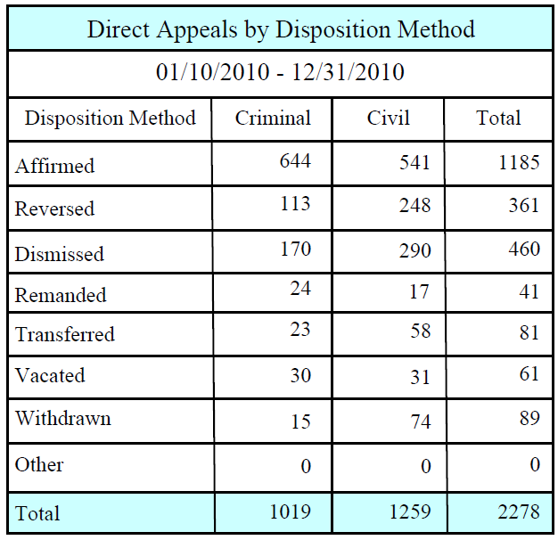

The Criminal and Civil columnsare the number of cases where the opinion date is between the reports begin and end date, CriminalCivilType = (0 - Criminal or 1 - Civil), CaseType = A, and Judgment Code is one of the following:
Affirmed: (02-001,02-013,02-019,02-020,02-028,02-029,02-042,02-070,02-080,02-099,02-231)
Reversed: (02-002,02-003,02-007,02-010,02-012,02-014,02-016,02-021,02-026,02-030,02-032,02-033,02-036,02-038,02-040,02-041,02-043,02-044,02-051,02-058,02-065,02-069,02-070,02-212,02-223,02-301,02-306,02-310)
Dismissed:(05-354,05-404,05-679,02-006,02-015,02-017,02-027,02-039,02-052,02-060,02-061,02-071,02-230,02-233,02-303,02-308,02-309 02-306, 02-222)
Remanded:(05-190,05-406,02-005,02-009,02-054,02-057,02-064,02-109,02-209,02-218,02-232,02-307)
Transferred: (05-405,02-023,02-024)
Vacated:(05-181,05-908,02-008,02-011,02-018,02-025,02-031,02-034,02-037,02-046,02-062,02-068,02-072,02-073,02-214,02-222,02-300,02-304,02-305,02-311,02-501,02-601)
Withdrawn:(05-357,02-004,02-115,02-213, 02-501)
Other: (05-040,02-056,02-067,02-074,02-108,02-208,02-216,02-217,02-219,02-225,02-603)

Applications Disposed Table

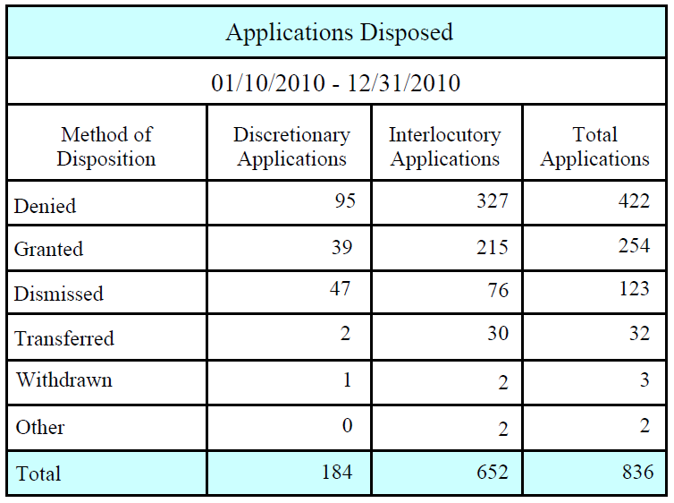

The Discretionary Applications and Interlocutory Applications columns are the number of cases where the opinion date is between the reports begin and end date, Criminal Civil Type = (0 - Criminal or 1 - Civil), Case Type = I or Case Type = D, and Judgment Code is one of the following:
Denied: (02-066,02-101,02-201) *02-066 Application Denied/Remande d with Direction is a code which does not distinguish if it is case type I or D. A new code should be created so that one code can be D with the same description as the I version so that case dispositions will not be counted twice.
Granted: (02-100,02-200)
Dismissed: (02-102,02-103,02-202,02-203)
Transferred: (02-104,02-204)
Withdrawn: (05-357,02-004,02-115,02-213) (02-107,02-207)
Other: (02-107,02-207) (02-108,02-208, 02-209, 02-308 02-603)
There should also be a applications disposed by case type chart. The difference in it and the above chart is the three columns should be criminal, civil and total. The criminal column is the number of cases where the opinion dates is between the reports begin and end date, Criminal Civil Type = 0 , Case Type is I or D and Judgement Code is one of the following while the civil column is the number of cases where the opinion dates is between the reports begin and end date, Criminal Civil Type = 1, Case Type is I or D and Judgment Code is one of the following:
Denied: (02-066,02-101,02-201) *02-066 Application Denied/Remande d with Direction is a code which does not distinguish if it is case type I or D. A new code should be created so that one code can be D with the same description as the I version so that case dispositions will not be counted twice.
Granted: (02-100,02-200)
Dismissed: (02-102,02-103,02-202,02-203)
Transferred: (02-104,02-204)
Withdrawn: (05-357,02-004,02-115,02-213) (02-107,02-207)
Other: (02-107,02-207) (02-108,02-208, 02-209, 02-308 02-603)

Applications Direct Appeals Disposed Table

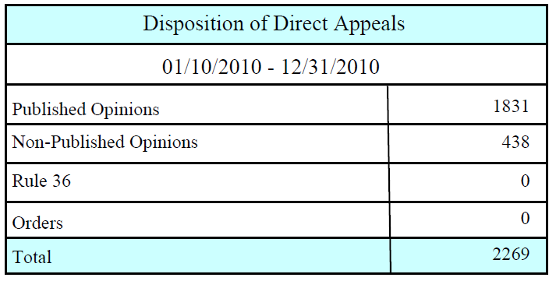
Published Opinions is number of cases where the opinion date is between the reports begin and end date, Case Type = A, Do Not Publish = 0, Rule 36 = 0, and Disposed of by Order = 0
Non-Published Opinions is the number of cases where the opinion date is between the reports begin and end date, Case Type = A, and Do Not Publish = 1 and Disposed by Order = 0
Rule 36 is the number of cases wherethe opinion date is between the reports begin and end date, Case Type = A, and Rule 36 = 1 and Disposed by Order = 0
Orders is the number of cases wherethe opinion date is between the reports begin and end date, Case Type = A, and Disposed of by Order = 1

Detailed Reports

In addition to the tables this report also includes the following detailed reports for theDirect Appeals by Disposition Method and Application Disposed tables:
- Criminal Disposition Detail
- Civil Disposition Detail
- Discretionary Applications Detail
- Interlocutory Applications Detail

Each of the detailed reports contains the following columns:
- Classification - Unique id for the Judgment Code.
- Code - Judgment Code
- Description– Judgment Code Description
- Count–Number of cases for the current Judgment Code

Criminal Direct Appeal Disposition Detail

The Classification, Code, Description, and Count are selected from the database where the OpinionDate is between the reports begin and end date, Case Type = A, Criminal Civil Type = 0, and Judgment Code is one of the following:
02-001,02-013,02-019,02-020,02-028,02-029,02-042,02-070,02-080,02-099,02-231,02-002,02-003,02-007,02-010,02-012,02-014,02-016,02-021,02-026,02-030,02-032,02-033,02-036,02-038,02-040,02-041,02-043,02-044,02-051,02-058,02-065,02-069,02-070 (duplicate see line one),02-212,02-223,02-301,02-306,02-310,05-354,05-404,05-679,02-006,02-015,02-017,02-027,02-039,02-052,02-060,02-061,02-071,02-230,02-233,02-303,02-308,02-309,05-190,05-406,02-005,02-009,02-054,02-057,02-064,02-109,02-209,02-218,02-232,02-307,05-405,02-023,02-024,05-181,05-908,02-008,02-011,02-018,02-025,02-031,02-034,02-037,02-046,02-062,02-068,02-072,02-073,02-214,02-222,02-300,02-304,02-305,02-311,02-501,02-601,05-357,02-004,02-115,02-213,05-040,02-056,02-067,02-074,02-108,02-208,02-216,02-217,02-219,02-225,02-603, 02-222

Example:

Criminal Dispositions Detail

Classification Code Description Count
511 02-001 AFFIRMED 641
512 02-002 REVERSED 76
513 02-003 AFFIRMED IN PART/REVERSED IN PART 21
Continued...

Civil Disposition Detail

The Classification, Code, Description, and Count are selected from the database where the OpinionDate is between the reports begin and end date, Case Type = A, Criminal Civil Type = 1, and Judgment Code is one of the following:
02-001,02-013,02-019,02-020,02-028,02-029,02-042,02-070 (duplicate see line three),02-080,02-099,02-231,02-002,02-003,02-007,02-010,02-012,02-014,02-016,02-021,02-026,02-030,02-032,02-033,02-036,02-038,02-040,02-041,02-043,02-044,02-051,02-058,02-065,02-069,02-070,02-212,02-223,02-301,02-306,02-310,05-354,05-404,05-679,02-006,02-015,02-017,02-027,02-039,02-052,02-060,02-061,02-071,02-230,02-233,02-303,02-308,02-309,05-190,05-406,02-005,02-009,02-054,02-057,02-064,02-109,02-209,02-218,02-232,02-307,05-405,02-023,02-024,05-181,05-908,02-008,02-011,02-018,02-025,02-031,02-034,02-037,02-046,02-062,02-068,02-072,02-073,02-214,02-222,02-300,02-304,02-305,02-311,02-501,02-601,05-357,02-004,02-115,02-213,05-040,02-056,02-067,02-074,02-108,02-208,02-216,02-217,02-219,02-225,02-603, 02-222

Example:

Civil Dispositions Detail

Classification Code Description Count
511 02-001 AFFIRMED 540
512 02-002 REVERSED 158
513 02-003 AFFIRMED IN PART/REVERSED IN PART 48
Continued...

Discretionary Applications Detail

The Classification, Code, Description, and Count are selected from the database where the OpinionDate is between the reports begin and end date, Case Type = I or Case Type = D, Criminal Civil Type = 0, and Judgment Code is one of the following:

02-004,02-066,,,,02-115,02-200,02-201,02-202,02-203,02-204,02-207,02-213,05-357 , 02-208, , 02-308, 02-603

Example:

Discretionary Applications Detail

Classification Code Description Count
514 02-004 WITHDRAWN 1
584 02-100 INTERLOCUTORY APPLICATION GRANTED 19
585 02-101 INTERLOCUTORY APPLICATION DENIED 47
Continued...

Interlocutory Applications Detail

The Classification, Code, Description, and Count are selected from the database where the OpinionDate is between the reports begin and end date, Case Type = I or Case Type = D, Criminal Civil Type = 1, and Judgment Code is one of the following:

02-004,02-066,02-100,02-101,02-102,02-103,02-104,02-107,02-115,02-200,02-201,02-202,02-203,02-204,02-207,02-213,05-357 02-108 02-209

Example:

Interlocutory Applications Detail

Classification Code Description Count
514 02-004 WITHDRAWN 2
584 02-100 INTERLOCUTORY APPLICATION GRANTED 101
585 02-101 INTERLOCUTORY APPLICATION DENIED 135
Continued...

Report Totals

- The Criminal Disposition Detail total will match the Criminal column total of the Direct Appeals by Disposition Method table.

- The Civil Disposition Detailtotal will match the Civil column total of the Direct Appeals by Disposition Method table.

- The Discretionary Applications Detail total will match the Discretionary Applications column total of the Application Disposed table.

- The Interlocutory Applications Detail total will match the Interlocutory Applications column total of the Application Disposed table.

- The Total Dispositions (Grand Total) is the Direct Appeals by Disposition Method table total + the Applications Disposed table total.

